Section | CUBS delete as appropriate
Week | 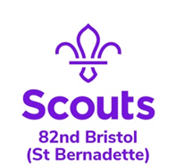  6 |  | Date | 27/05/2020
Zoom Meeting Recap:
We started the session with our Grand Howl.

Tonight was the launch of our new Badge – “Stay connected”. This is a limited-edition special badge that we hope for lots of you to achieve!

To start this badge, we all iced and then decorate biscuits – they looked delicious!

We then played some games.

We finished the night doing the Grand Howl just like at the HQ!
Scouting from home task:
Badge/Activity |  | Stay connected
Requirements |  | Have a look at the stay connected badge (information on the website) and pick an activity to do
Your Task |  | If you missed tonight’s session that have a go at decorating your own biscuits and send us a picture!
Useful Resources
Next Step |  | Have a look at the Stay Connected badge – we will be completing this over the next few weeks during our Cub sessions but there are lots of things you could complete at home too!

