Section | CUBS delete as appropriate
Week | 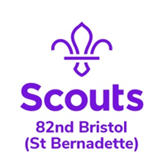  4 |  | Date | 13/05/2020
Zoom Meeting Recap:
We started the session by doing our Grand Howl just like at the HQ

We had a night having fun and playing some games!

Scouting from home task:
Badge/Activity |  | Team work
Requirements
Your Task |  | This week and next week we are having Cub Games nights on Zoom – just to have a bit of fun but it is also going towards our Teamwork and Team Leader challenge badges at the same time.  We will be launching a new badge next week!
Useful Resources |  | If anyone wants to complete any badges in their own time please have a look at:  https://www.scouts.org.uk/cubs/activity-badges/
Next Step |  | See you next week!

