Section | CUBS delete as appropriate
Week | 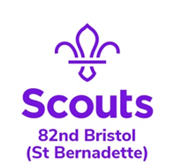  3 |  | Date | 06/05/2020
Zoom Meeting Recap:
First the Leaders showed off some BSL they had been learning this week and then some of the Cubs shared them finger spelling their names – You all did SO WELL practising this, this week. This completes the disability badge for everyone that has completed all of the tasks! Well done!

Angela shared some bunting she has been busy making for VE Day and all the Cubs have all been challenged to make bunting and have it up on Friday.

We finished the session by taking part in Sean’s VE Quiz – this counts towards our VE Badge!

Well done everyone for joining in and looking so smart in your Cubs uniform. We loved seeing you as we are missing you lots!

See you next week for a session of nothing but games!

Scouting from home task:
Badge/Activity |  | VE Badge
Requirements |  | Complete 1 task from each section and an additional one of your choice
Your Task |  | Have a look at the VE Day Badge requirements and choose an activity or two to complete this week. Don’t forget to ask your grown up to email it to Jemma or share it on Facebook with us!
Useful Resources |  | N/A
Next Step |  | Work towards you VE day badge and DO NOT forget to join us for our family fun quiz on Friday!

