Section | CUBS delete as appropriate
Week | 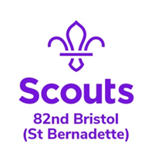  10 |  | Date | 24/06/2020
Zoom Meeting Recap:
We started the session with our Cub Howl.

James thanked all the Cubs that sent him a message and photo for his 16th Birthday.

We had a games night and played a bring me game followed by a challenge to make “50” with items found in the kitchen. Finally we played an alphabet game!

We finished with the Cub howl just like at the HQ.
Scouting from home task:
Badge/Activity |  | Fitness Challenge / Athletics
Requirements |  | Next week we are going to be taking part in Yoga / Fitness video as part of our fitness challenge and athletics badges.  You will need to be able to see your computer screen but also have enough space to join in – we know some Cubs may feel nervous about this so we do not mind if Cubs turn their video off while taking part! Make sure you have suitable clothes (Cub uniform is not necessary) and a drink in case you get thirsty!
Your Task
Useful Resources
Next Step

