Section | BEAVERS delete as appropriate
Week | 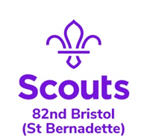  3 |  | Date | 06/05/2020
Zoom Meeting Recap:
First Clare held up Beaver signs for us to spell out Beavers just like we would at the HQ on a Beaver night.

We all then shared our book marks – there were so many and they looked great. Debbie shared a book she had been reading and then we all talked about a character for a book we had been reading.

We showed bunting we have been busy making for VE Day and we have all been challenged to make bunting and have it up on Friday.

We played an animal noise game, recognised some famous people in Scouting like Bear Grylls, The Queen and Baden Powell. Finally, we guessed some flags as Clare held them up.

We finished off the session by spelling BEAVERS again.

Well done everyone for joining in and looking so smart in your Beaver uniform. We loved seeing you as we are missing you lots!

See you next week!

Scouting from home task:
Badge/Activity |  | VE Badge
Requirements |  | Complete 1 task from each section
Your Task |  | Have a look at the VE Day Badge requirements and choose an activity or two to complete this week. Don’t forget to ask your grown up to email it to Jemma or share it on Facebook with us!
Useful Resources |  | N/A
Next Step |  | Work towards you VE day badge and DO NOT forget to join us for our family fun quiz on Friday!

